**TUGAS WEB PROGAMMING II**

NIM : 12200796

NAMA : ANGGI HIKMAH PUTRI

KELAS : 12.3B.13

**Berikut hasil output dari latihan yang ada dipertemuan 6**

1. **Merancang & Membuat Database Aplikasi pustaka-booking dan Konfigurasi database di Codeigniter**

**Link :** [**http://localhost/phpmyadmin/index.php?route=/sql&db=pustaka&table=buku&pos=0**](http://localhost/phpmyadmin/index.php?route=/sql&db=pustaka&table=buku&pos=0)

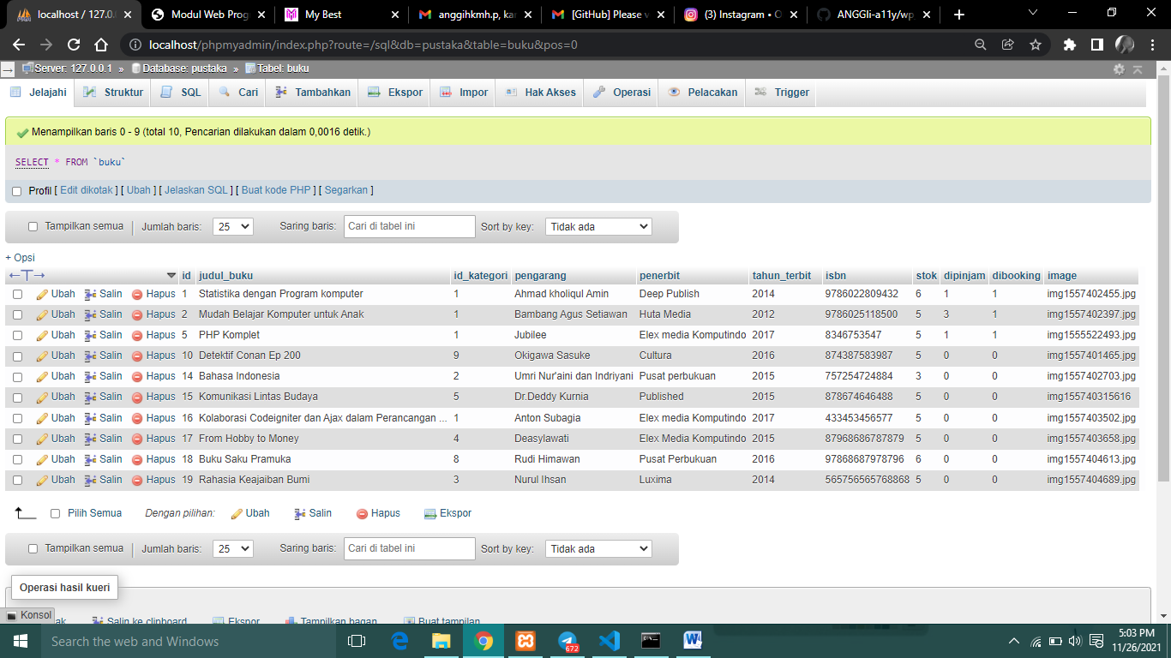

**Link :** <http://localhost/phpmyadmin/index.php?route=/sql&db=pustaka&table=kategori&pos=0>

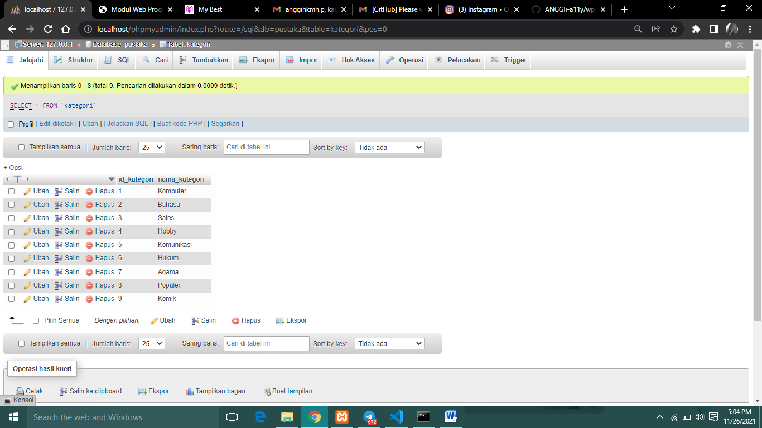

**Link :** [**http://localhost/phpmyadmin/index.php?route=/sql&db=pustaka&table=role&pos=0**](http://localhost/phpmyadmin/index.php?route=/sql&db=pustaka&table=role&pos=0)

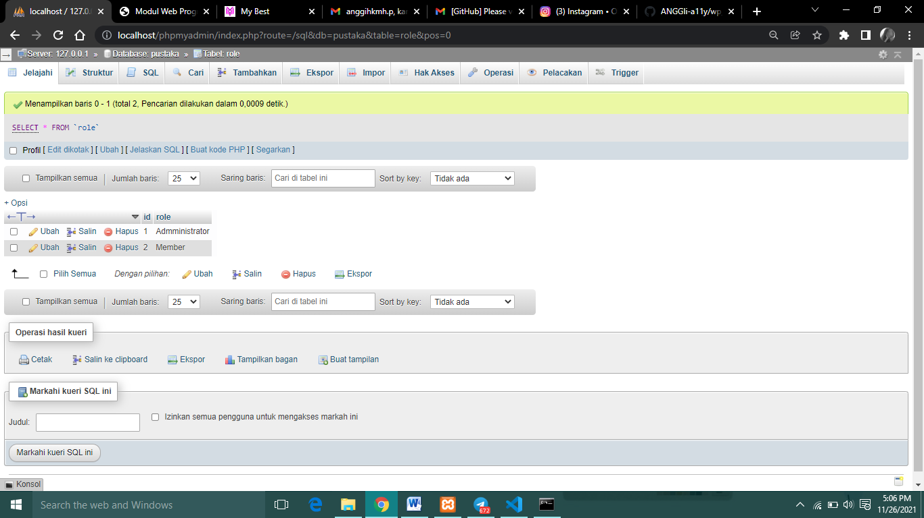

**Link :** [**http://localhost/phpmyadmin/index.php?route=/table/structure&db=pustaka&table=user**](http://localhost/phpmyadmin/index.php?route=/table/structure&db=pustaka&table=user)

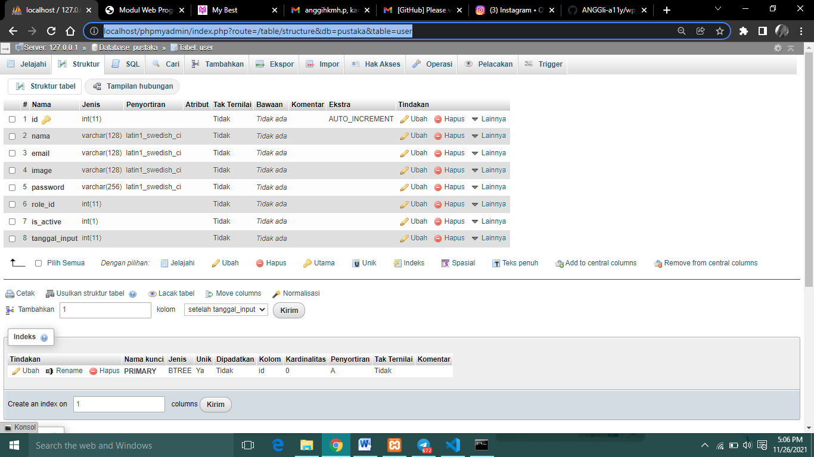

1. **Tampilan setelah di push**

**Link :** [**https://github.com/ANGGIi-a11y/wp_anggi**](https://github.com/ANGGIi-a11y/wp_anggi)

